ASSEMBLY LANGUAGE - **MICROWAVE PROJECT**

**DESCRIPTION**

The aim of this project is to implement the basic functionalities of a microwave like turning it on, hibernating, setting the modes of operation(COOKING & WARMING), taking the time span in which the user wishes to warm and cook his/her food and so on using ASSEMBLY LANGUAGE.

**USAGE**

The code when run, asks the user whether he/she wants to turn on the microwave or hibernate. Whatever the input is the corresponding response is given according. The code goes ahead to display the name of the brand and asks the user whether he/she wishes to COOK or WARM. If the right is given, the user is given the screen to go ahead and give the time span in which the food is to be cooked or warmed.

**USER MANUAL**

**Introduction:**

This program implementing a MICROWAVE, allows you to cook or warm your food to suite your liking. **Running the program:**

To run this program the user has to first have all necessary packages to compile this program. On Linux(UBUNTU specifically) the user has to open the terminal and run the command. **sudo apt install nasm.**

After installing NASM running the program won’t be difficult as long as you follow the following steps

1. Open your terminal and change the directory to the folder containing the **.asm** file.
2. Enter the following command to create the object file **nasm -f elf32 -o microwave.o microwave.asm**
3. Followed by **ld -m elf_i386 -o microwave microwave.o** (d) After creating the executable file, go ahead and run the program by typing

**./microwave**

1. You should see this if your code running was successful

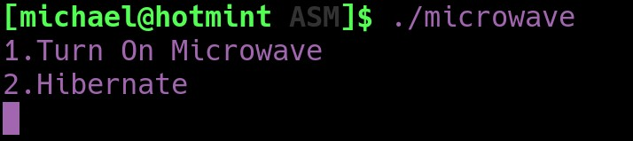

1. To continue, choose 1 and hit enter. You should see the below after hitting 1

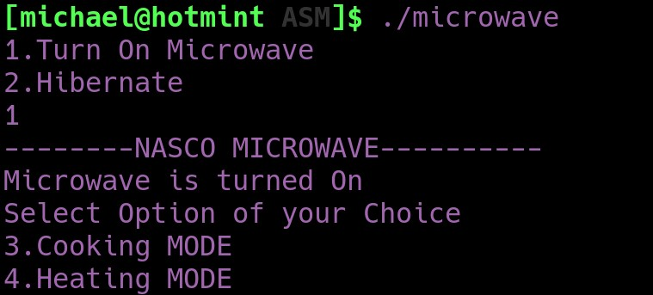

1. After being presented with this option, go ahead and choose your desired mode of operation.

Either choice of operation will present you with the option to set your cook time as seen below

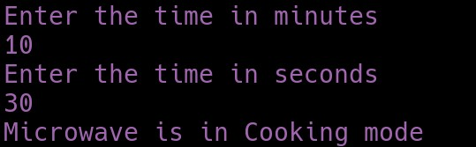

You are prompted to enter your cook time in minutes and also in seconds. VOILAAAA... The microwave code then starts to perform the given instructions…

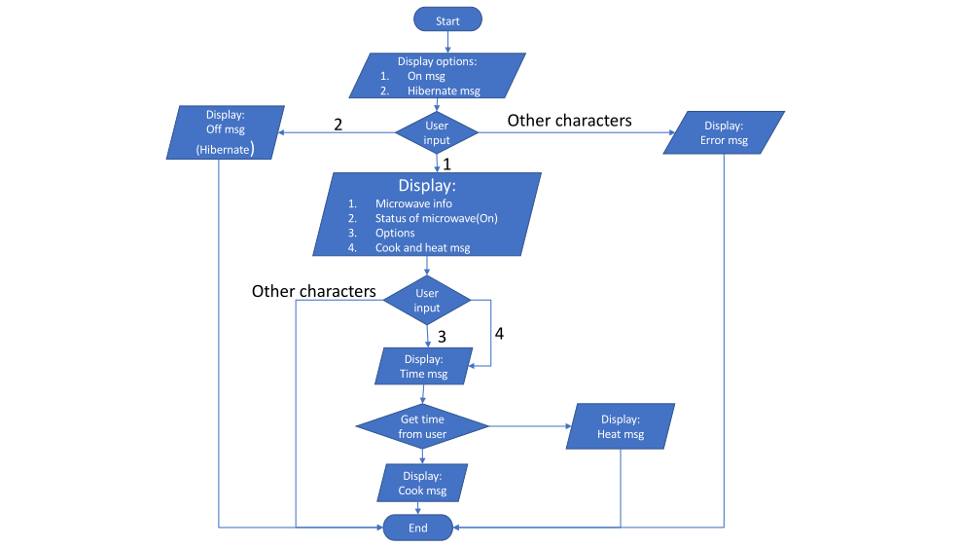

FLOWCHART OF THE PROGRAM

**SOURCE CODE**

;MICROWAVE

%macro DisplayText 2 mov eax, 4 mov ebx, 1 mov ecx, %1 mov edx, %2 int 0x80

%endmacro %macro TakeInput 2 mov eax, 3 mov ebx, 2 mov ecx, %1 mov edx, %2 int 0x80

%endmacro

section .data outMsg db "--------NASCO MICROWAVE----------",0xa,0xd outMsgLen equ $-outMsg

onMsg db "1.Turn On Microwave",0xa,0xd onMsgLen equ $-onMsg

offMsg db "2.Hibernate",0xa,0xd offMsgLen equ $-offMsg

on_Msg db "Microwave is turned On",0xa,0xd on_MsgLen equ $-on_Msg

off_Msg db "Microwave is Hibernated",0xa,0xd off_MsgLen equ $-off_Msg

option db "Select Option of your Choice",0xa,0xd optionLen equ $-option

cookMsg db "3.Cooking MODE",0xa,0xd cookMsgLen equ $-cookMsg

cook_Msg db "Microwave is in Cooking mode",0xa,0xd cook_MsgLen equ $-cook_Msg

reheatMsg db "4.Heating MODE",0xa,0xd reheatMsgLen equ $-reheatMsg

reheat_Msg db "Microwave is in Heating mode",0xa,0xd reheat_MsgLen equ $-reheat_Msg

minute db "Enter the time in minutes",0xa,0xd minutelen equ $-minute

second dq "Enter the time in seconds",0xa,0xd secondlen equ $-second

invalidInput db "You have entered an invalid response",0xa,0xd invalidInputLen equ $-invalidInput

;setting constant opt1 equ '1' opt2 equ '2' opt3 equ '3' opt4 equ '4'

section .bss num resb 4 num1 resb 4 min resb 4 sec resb 4 section .text global _start _start:

;Display output for option

DisplayText onMsg, onMsgLen

DisplayText offMsg, offMsgLen

;Read input

TakeInput num, 4

mov dl,[num] cmp dl,opt1

JE n01

cmp dl,opt2

JE n02

JMP exit

n01:

DisplayText outMsg, outMsgLen

DisplayText on_Msg, on_MsgLen

DisplayText option, optionLen

DisplayText cookMsg, cookMsgLen

DisplayText reheatMsg, reheatMsgLen ;Read another input

TakeInput num1, 4

mov dl,[num1] cmp dl,opt3

JE n03

cmp dl,opt4

JE n04

JMP exit

time:

;Text requesting input to operate microwave(minute)

DisplayText minute, minutelen

TakeInput min, 4

;Text requesting time in secocnds to operate the microwave

DisplayText second, secondlen

TakeInput sec, 4

ret

n03: call time

DisplayText cook_Msg, cook_MsgLen

mov eax,1 int 0x80

n04: call time DisplayText reheat_Msg, reheat_MsgLen

mov eax,1 int 0x80

n02:

DisplayText off_Msg, off_MsgLen

mov eax,1 int 0x80

exit:

DisplayText invalidInput, invalidInputLen

mov eax, 1 int 0x80

**MEMBERS**

Quam Michael Donkor - 9411619

Babasola Duduyemi - 9403419

Benjamin Adzibolosu - 9415519

Adjei Jespa Bawuah - 9391719

Eturu Gyasiwaa Emmauella - 9404219

Lansah Josiah - 4623118

Boakye Rasford – 9401319

Kwaku Antwi Basoah – 9400219

Majid Ziad - 9407519